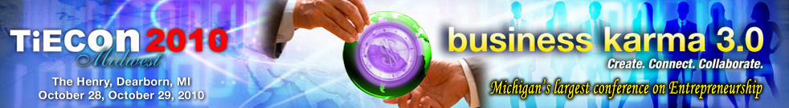

Contact: Tel K. Ganesan
(248) 254-4013
tel.ganesan@detroit.tie.org

TiECon 2010 Midwest – Business Karma 3.0

Farmington Hills, MI, August 31, 2010— TiE Detroit announces its third annual TiECon 2010 Midwest: Business Karma 3.0, scheduled for October 28 and 29, 2010 at The Henry in Dearborn, Michigan (formerly known as the Ritz-Carlton).
Creativity and Innovation are the primary drivers of entrepreneurial success. Create, Connect and Collaborate with the right set of people to attain success and profit without compromising your focus on Talent, Ideas and Enterprise. Business Karma 3.0 focuses on holistically integrating all business levels to help entrepreneurs at all stages, from those in the planning phase to startups and emerging companies.
“TiECon Midwest 2010 is the largest entrepreneurial conference in Michigan and comes with the theme Business Karma 3.0- Create. Connect. Collaborate. Come and listen to the dreams, stories, and insights of speakers at TiECon 2010, engage in rich dialogue with entrepreneurs, venture capitalists, industry executives and walk away with wealth of knowledge, inspiration and solid business contacts,” says Tel K. Ganesan, President, TiE Detroit.

TiECon 2010 Midwest features various activities throughout the two-action packed days; including Extreme Power Connect; multiple sessions based on a mixture of content areas including Information Technology, Women’s Forum, Global Transactions and Emerging Trends; TiE 20 awards, keynote speakers from numerous organizations and the annual Business Plan Competition. The conference is hosting TiE20 Awards which will showcase an elite group of Top 20 of the most promising startup and emerging companies across TiECon Midwest’s four major focus segments - Internet, Software, Mobile and Media.

Additionally, TiECon Midwest 2010 features include:
- Extreme Power Connect- A focused networking session that will facilitate the gleaning of a variety of perspectives from veteran business leaders with insights into the challenges entrepreneurs encounter in starting or growing a company.
- Business Plan Competition- A platform for aspiring entrepreneurs, including both seasoned professionals and students, to turn great ideas and dreams into high quality business plans and eventually into successful businesses.
- High powered keynote speakers from all over the world will discuss trends in Information Technology, Women’s Forum, Global Transactions and Emerging Trends

Business Karma 3.0 is all about creating, connecting and collaborating your current business life to determine your future stake in success! Powerful panel discussions, several hot and emerging content discussions, an award banquet and a spectacular display of entertainments and fun will add more colors to this evening at TiECon 2010.
Online registration and more information are immediately available for TiECon Midwest 2010 at http://www.tieconmidwest.org/ and http://www.detroit.tie.org/ For more information about the conference, please contact Jessica Matthews, Conference Coordinator, TiE Detroit (248) 254-4013 or via e-mail at jessica@tieconmidwest.org

Download PDF Version: Business Karma 3.0 Flyer
TiE (The Global Network of Entrepreneurs) is a global, nonprofit organization dedicated to fostering entrepreneurs internationally and is sponsored by top Venture Capital Firms, and Fortune 500 corporations; extending across 12 countries with 53 chapters, 1,800 experienced entrepreneurs and business executives as charter members, 12,000 aspiring entrepreneurs and professionals as members. TiE has grown to become the world’s largest nonprofit organization for entrepreneurs. Learn more about the TiE Detroit chapter at http://www.detroit.tie.org/

28230 Orchard Lake Road, Suite 110 Farmington Hills, MI 48334
Phone: (248) 254-4013 Fax: (248) 254-4011
Conference Coordinator: Jessica Matthews, Email: jessica@tieconmidwest.org

