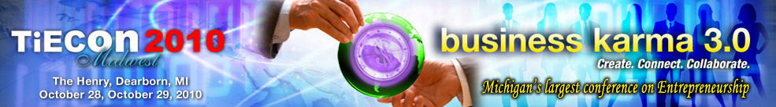

TiE Detroit announces David Egner as Keynote Speaker for
TiECon Midwest 2010

Farmington Hills, MI, Sept. 21, 2010—The Detroit chapter of TiE (Talent, Ideas, Enterprise) today announced that David Egner, New Economy Initiative executive director and president and CEO of the Hudson-Webber Foundation, will deliver a keynote speech at TiECon Midwest 2010, Michigan’s largest conference on entrepreneurship to be held Oct. 28 and 29, 2010 at The Henry, Dearborn.

”We are honored and privileged to have David Egner deliver a keynote address at the conference. Dave is a visionary who encourages innovation and entrepreneurship and is committed to accelerate the transition of southeast Michigan to an innovation economy,” says Tel Ganesan, TiE Detroit president.

David Egner leads the Hudson-Webber Foundation in its mission to improve the vitality and quality of life of the metropolitan Detroit community with a particular interest in the revitalization of the urban core. He is also the executive director of the $100 million New Economy Initiative. Prior to joining the Foundation, Egner served as president and CEO of the Michigan Nonprofit Association. Before joining MNA, he was executive assistant to the chairman and CEO of the W.K. Kellogg Foundation. He was also director of operations for Junior Achievement Inc. and president of Junior Achievement of Springfield and Sangamon Valley, Inc. in Springfield, Illinois.

Online registration and more information are immediately available for TiECon Midwest 2010 at http://www.tieconmidwest.org/ and http://www.detroit.tie.org/. For more information about the conference, please contact Jessica Matthews, Conference Coordinator, TiE Detroit (248) 254-4013 or via e-mail at jessica@tieconmidwest.org

About TiECon Midwest 2010
TiECon Midwest 2010 is Michigan's Largest Conference on entrepreneurship. Business Karma 3.0 is all about taking the innovative streak in you to create connect and collaborate your current business life to determine your future stake in success. TiECon 2010 Midwest also features various activities including Extreme Power Connect, TiE 20 awards, keynote speakers from numerous organizations and the annual Business Plan Competition. The conference also highlights four sessions based on a mixture of content areas which includes Information Technology, Health Care, Women’s Forum, Global Transactions and Emerging Trends. TiECon 2010 is also hosting TiE20 Midwest Awards which will showcase an elite group of Top 20 of the most promising startup and emerging companies across TiECon Midwest’s four major focus segments - Internet, Software, Mobile and Media. For more information, visit http://www.tieconmidwest.org/

About TiE
TiE (The Global Network of Entrepreneurs) is a global, nonprofit organization dedicated to fostering entrepreneurs internationally and is sponsored by top Venture Capital Firms, and Fortune 500 corporations; extending across 12 countries with 53 chapters, 1,800 experienced entrepreneurs and business executives as charter members, 12,000 aspiring entrepreneurs and professionals as members. TiE has grown to become the world’s largest nonprofit organization for entrepreneurs. Learn more about the TiE Detroit chapter at www.detroit.tie.org/.

Press Contacts:

Tel K. Ganesan
(248) 254-4013
tel.ganesan@detroit.tie.org

Sue Voyles
Logos Communications, Inc.
734-667-2005 / sue@logos-communications.com

28230 Orchard Lake Road, Suite 110 Farmington Hills, MI 48334
Phone: (248) 254-4013 Fax: (248) 254-4011
Conference Coordinator: Jessica Matthews, Email: jessica@tieconmidwest.org

