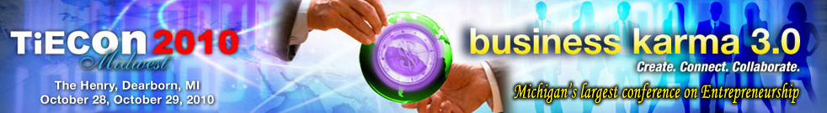

TiE Detroit announces TiE20 Midwest Finalists

Farmington Hills, MI, October 18, 2010 - The Detroit chapter of TiE also known as Talent, Ideas, Enterprise today announced the Finalists for the annual TiE20 Midwest Awards for their annual conference, TiECon Midwest, to be held at The Henry Dearborn, October 28 and 29, 2010.

“We recognize and appreciate the finalists whose metrics have stood out among their peers. TiE20 Awards provide startups a unique platform for visibility, networking and mentoring opportunities through TiE’s global ecosystem, said Tel Ganesan, President, TiE Detroit Chapter.

TiECon Midwest 2010 is an entrepreneurial conference attracting hundreds of entrepreneurs, venture capitalists and professionals. TiE20 Awards recognizes excellence among 20 Early Stage Startups within four industry verticals: Internet, Software, Mobile, and Media. TiE20 winners (5 per domain) will be honored with awards of excellence in front of several well established Entrepreneurs, Venture Capitalists, Industry Experts and other business professionals during TiEcon Midwest. Additionally, the TiE20 winners will present their companies in a live showcase at the conference and get special invitations to PowerConnect premium networking sessions. They will also be a part of the ongoing recognition from TiE Detroit throughout the year.

“The finalists hold place of pride for being selected from hundreds of nominations and will now go through the next stage of judging and public polling before declaring the winners. We wish them all the success and encourage their active participation in public polling for the winners spots,” said Mateen Syed, Chair TiE20 Midwest Awards.

For more information about TiE 20 Midwest Startup Awards, please contact Luxmi Sharma: sharma@tieconmidwest.org.

About TiECon Midwest 2010
TiECon Midwest is Michigan's Largest Conference on entrepreneurship, designed for the Innovative Entrepreneur who thinks creatively, innovatively and resourcefully to create their own future regardless of economic conditions and uncertainties. TiECon Midwest 2010 provides a unique opportunity to exchange ideas, explore new businesses, discuss emerging technologies, share growth strategies and obtain insight from global business leaders, community leaders and worldwide experts. For more information, visit http://www.tieconmidwest.org/

About TiE
TiE is a global, not-for-profit, non-political, and non-religious organization dedicated to fostering entrepreneurs across its international network sponsored by top Venture Capital Firms, and Fortune 500 corporations; spread across 53 chapters in 12 countries comprising 1800 experienced entrepreneurs and business executives as charter members, 12000 aspiring entrepreneurs and professionals as members. TiE has grown to become the world’s largest non-profit organization for entrepreneurs. For more information, visit http://www.detroit.tie.org/

Press Contacts:
Tel K. Ganesan
(248) 254-4013
tel.ganesan@detroit.tie.org

Sue Voyles
Logos Communications, Inc.
734-667-2005 / sue@logos-communications.com

28230 Orchard Lake Road, Suite 110 Farmington Hills, MI 48334
Phone: (248) 254-4013 Fax: (248) 254-4011
Conference Coordinator: Jessica Matthews, Email: jessica@tieconmidwest.org

