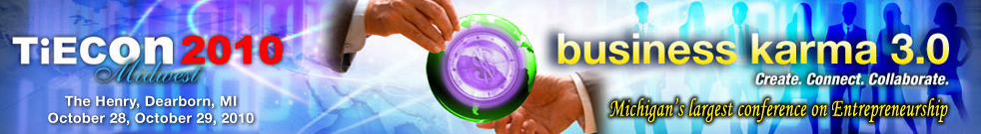

Global Midwest: Immigration & Innovation as Drivers Discussed at
TiECon Midwest 2010

Farmington Hills, MI, Oct. 13, 2010 - The Detroit chapter of TiE (Talent, Ideas, Enterprise) presents a discussion on Global Midwest: Immigration & Innovation as Drivers at TiECon Midwest 2010, Michigan’s largest Conference on entrepreneurship to be held Oct. 28 and 29, 2010 at The Henry, Dearborn.

In the early 20th century, it was the innovative and entrepreneurial spirit of European immigrants who invented the technologies, manufacturing processes and business practices that made America the world's economic leader. TiE Detroit’s track, Global Midwest: Immigration & Innovation as Drivers on Oct. 28, 2010, will discuss on how immigration and innovation will regenerate tarnished economies.

Speakers Rami D. Fakhoury, Steve Tobocman, Audrey Russo and Richard T. Herman will provide their insights on how to revitalize the Rust Belt. All conference attendees are encouraged and welcomed to join this interactive session. The speakers will discuss the inspiring initiatives (Global Detroit, Global Cleveland, Global Pittsburgh, etc.) launched throughout the Midwest to attract international talent and how entrepreneurism can reinvent regional economies and metropolitan areas.

“Immigration and Innovation are the key drivers to rebuild a ‘Global Midwest.’ Embracing and attracting immigrants, their entrepreneurial culture and global connections are critical to our region’s success in the New Economy. Immigrants bring with them skills to invent new technologies that will continue to drive job creation and regional prosperity,” says Tel K. Ganesan, TiE Detroit president.

Online registration and more information are immediately available for TiECon Midwest 2010 at http://www.tieconmidwest.org/ For more information about the conference, please contact Jessica Matthews, Conference Coordinator, TiE Detroit (248) 254-4013 or via e-mail at jessica@tieconmidwest.org

About TiECon Midwest 2010
TiECon Midwest 2010 is Michigan's Largest Conference on entrepreneurship. Business Karma 3.0 is all about taking the innovative streak in you to create connect and collaborate your current business life to determine your future stake in success. TiECon Midwest 2010 provides a unique opportunity to exchange ideas, explore new businesses, discuss emerging technologies, share growth strategies and obtain insight from global business leaders, community leaders and worldwide experts. For more information, visit http://www.tieconmidwest.org.
About TiE
TiE (The Global Network of Entrepreneurs) is a global, nonprofit organization dedicated to fostering entrepreneurs internationally and is sponsored by top Venture Capital Firms, and Fortune 500 corporations; extending across 12 countries with 53 chapters, 1,800 experienced entrepreneurs and business executives as charter members, 12,000 aspiring entrepreneurs and professionals as members. TiE has grown to become the world’s largest nonprofit organization for entrepreneurs. Learn more about the TiE Detroit chapter at www.detroit.tie.org.

Press Contacts:
Tel K. Ganesan
(248) 254-4013
tel.ganesan@detroit.tie.org

Sue Voyles
Logos Communications, Inc.
734-667-2005 / sue@logos-communications.com

28230 Orchard Lake Road, Suite 110 Farmington Hills, MI 48334
Phone: (248) 254-4013 Fax: (248) 254-4011
Conference Coordinator: Jessica Matthews, Email: jessica@tieconmidwest.org

