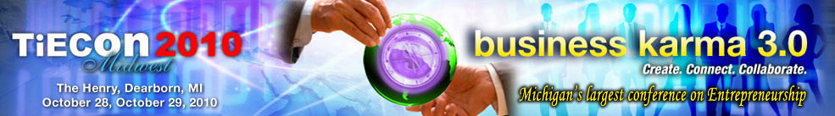

Detroit Chapter of TiE Inviting Submissions for
Business Plan Competition
$50,000 in cash and services will be awarded

Sept. 2, 2010 - The Detroit Chapter of TiE will hold its annual Business Plan Competition (BPC) during the TiECon Midwest 2010 Event on Oct. 28 and 29, 2010. In keeping with its mission of promoting innovation and entrepreneurship in the region, TiE offers the BPC as a platform, for aspiring entrepreneurs, seasoned professionals and students, to turn great ideas into effective business plans and eventually into successful businesses.

The objective of this contest is to promote the entrepreneurial spirit and the competition will give you an opportunity to compete with the best minds in Midwest and convert your idea into a full blown venture. The goals of the competition include:

- Promoting entrepreneurship in the Midwest across a broad spectrum of sectors
- Stimulating business development and consequent employment in the region
- Encouraging entrepreneurs with startup seed money, business services and mentoring

The top five business plans will be presented to the judges that will include venture capitalists, investment bankers and TiE charter members. These finalists will also be awarded a plaque and certificate of recognition.

The top three winners will have the opportunity to present their business during the awards ceremony at TiECon Midwest 2010 Event to an audience of serious investors and leading VC companies. The prizes include cash and in-kind business services (such as marketing, business coaching, legal and accounting) totaling $50,000. The winners will receive business coaching and mentorship and will also be featured in TiE media releases, TiE-Detroit website and will be showcased at select TiE events.

“The goal of the program is to locate the likes of Mark Zuckerberg of Facebook, sitting in the dorms of various universities,” says Tel K. Ganesan, President, TiE Detroit.
“For the first time, few companies have committed investment opportunities for the winners of the BPC, TiECon Midwest 2010, taking it beyond competition,” said Ganesan.
The submission deadline for the Executive Summary is October 11, 2010. Winners will be announced during an Awards ceremony during the TiECon Midwest 2010 Event on October 28. To learn more about the BPC, visit http://www.tieconmidwest.org/ or contact Jessica Matthews at TiE Detroit, (248) 254-4013 or Jessica@tieconmidwest.org.

TiECon Midwest 2010 features Extreme Power Connect and many other power packed sessions with relevant strategic information for companies, including a variety of keynote speakers, a Business Plan Competition and TiE 20 Industry Awards.

TiE (The Global Network of Entrepreneurs) is a global, nonprofit organization dedicated to fostering entrepreneurs internationally and is sponsored by top Venture Capital Firms, and Fortune 500 corporations; extending across 12 countries with 53 chapters, 1,800 experienced entrepreneurs and business executives as charter members, 12,000 aspiring entrepreneurs and professionals as members. TiE has grown to become the world’s largest nonprofit organization for entrepreneurs. Learn more about the TiE Detroit chapter at http://www.tieconmidwest.org/

Press contacts:
Tel K. Ganesan, President
TiE Detroit
28230 Orchard Lake Rd, Suite 110,
Farmington Hills, MI 48334.
248) 254-4010 X310 / tel.ganesan@detroit.tie.org

Sue Voyles
Logos Communications, Inc.
734-667-2005 / sue@logos-communications.com

28230 Orchard Lake Road, Suite 110 Farmington Hills, MI 48334
Phone: (248) 254-4013 Fax: (248) 254-4011
Conference Coordinator: Jessica Matthews, Email: jessica@tieconmidwest.org

